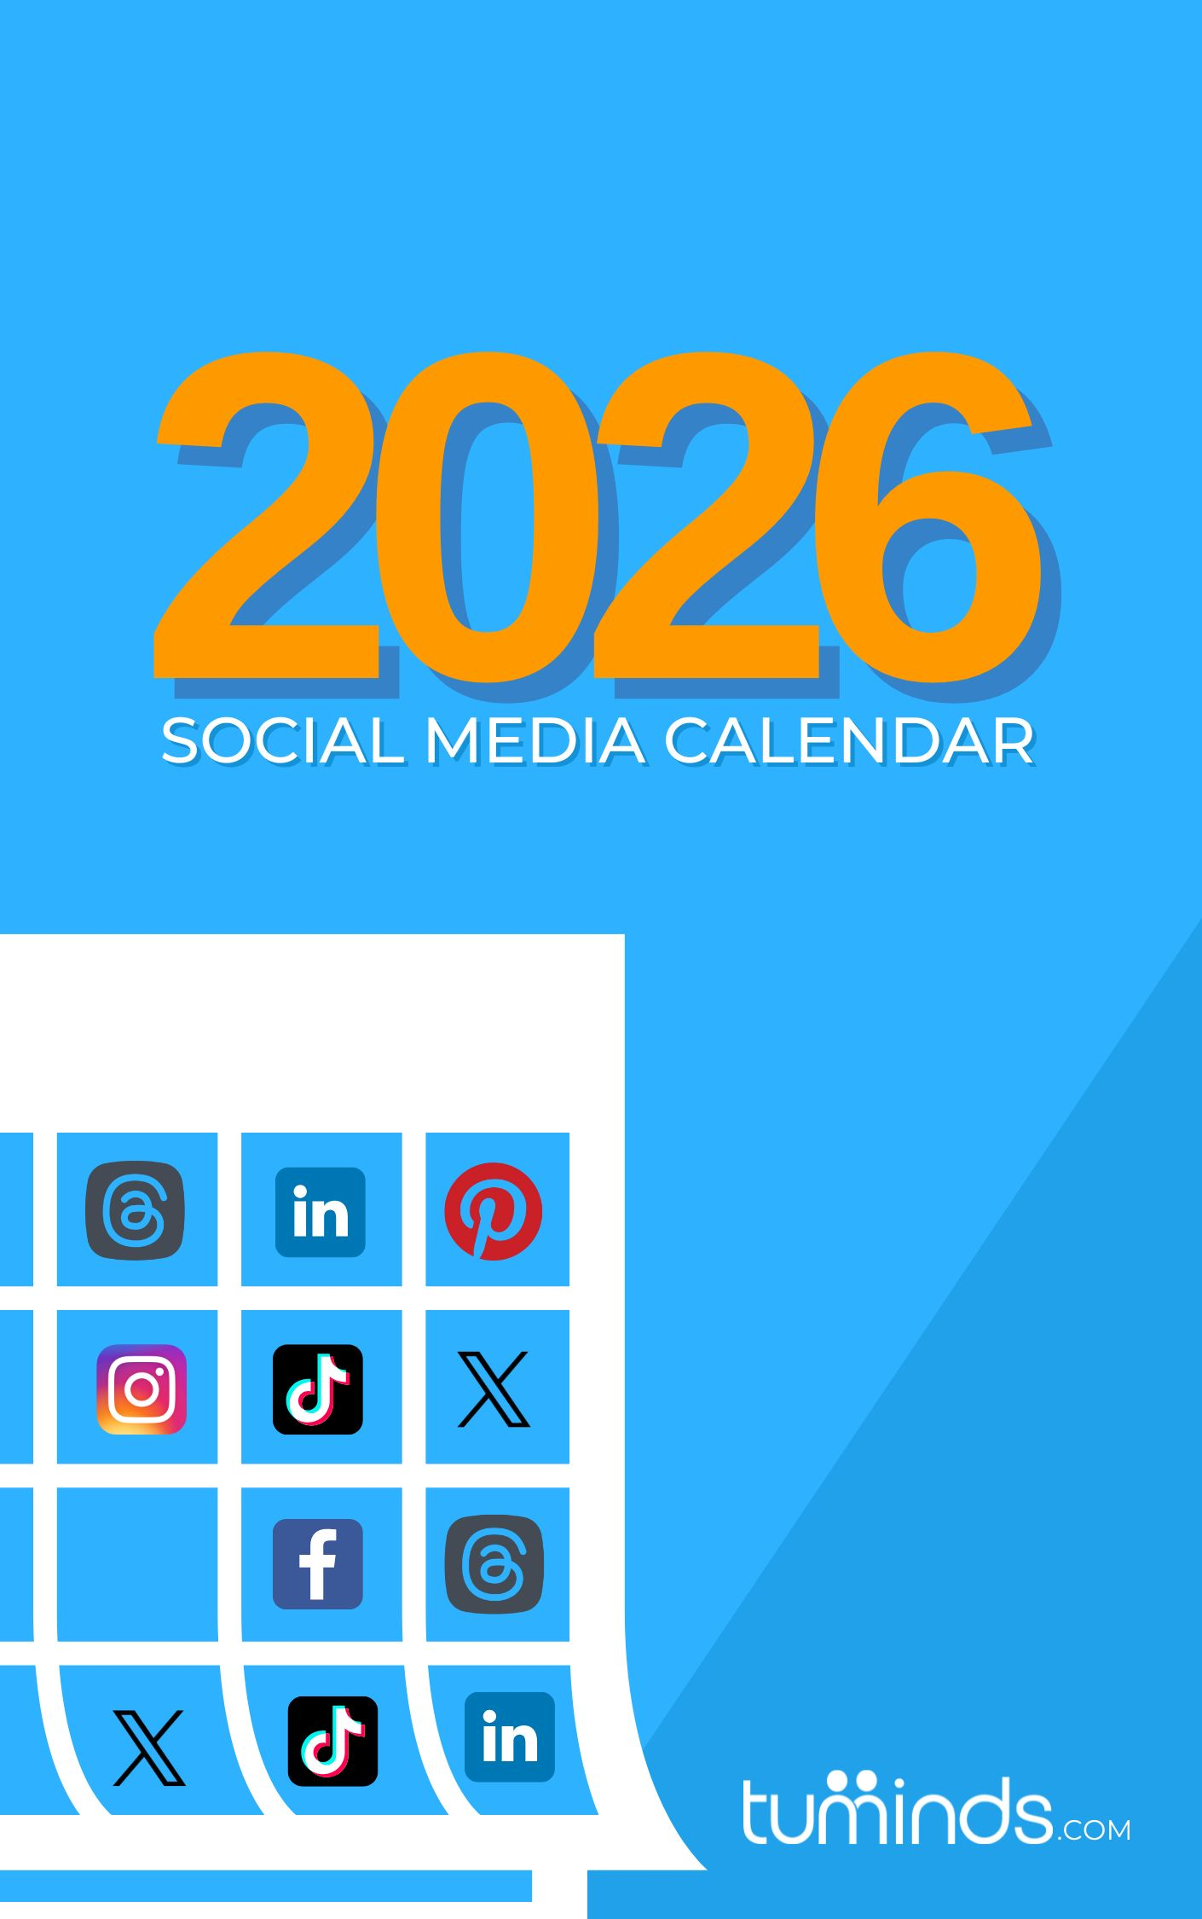

Welcome to the Tuminds 2026 Social Media Calendar!
In a world where time is a precious commodity, finding the right balance between running your business and maintaining an active online presence can be challenging. But don’t worry, we've got your back.
Our social media calendar is your trusty companion for crafting a well-organised and engaging online presence. Say goodbye to the chaotic scramble of last-minute posts and hello to effortless scheduling. Our calendar also has monthly tips and key dates already filled in.
At Tuminds, we provide hands-on, practical training on a range of topics such as AI, Search Engine Optimisation, creating captivating Instagram Reels and how to use email marketing to drive more sales. We also offer monthly support and coaching packages, digital audits and social media strategies designed to equip you with the tips and tools needed for digital success.
For the latest updates and invaluable tips, be sure to follow us on Facebook, X /Twitter, Instagram, TikTok, LinkedIn, Pinterest, Threads and subscribe to our YouTube channel if you're not already a part of our growing community.
Also, a quick update. We will be launching a new service called Digital Helpdesk in Q1 2026, an online service focused on fixing those small but annoying digital issues that are slowing you down.
Let's make 2026 your year of digital triumph! Happy planning from all of us at Tuminds!
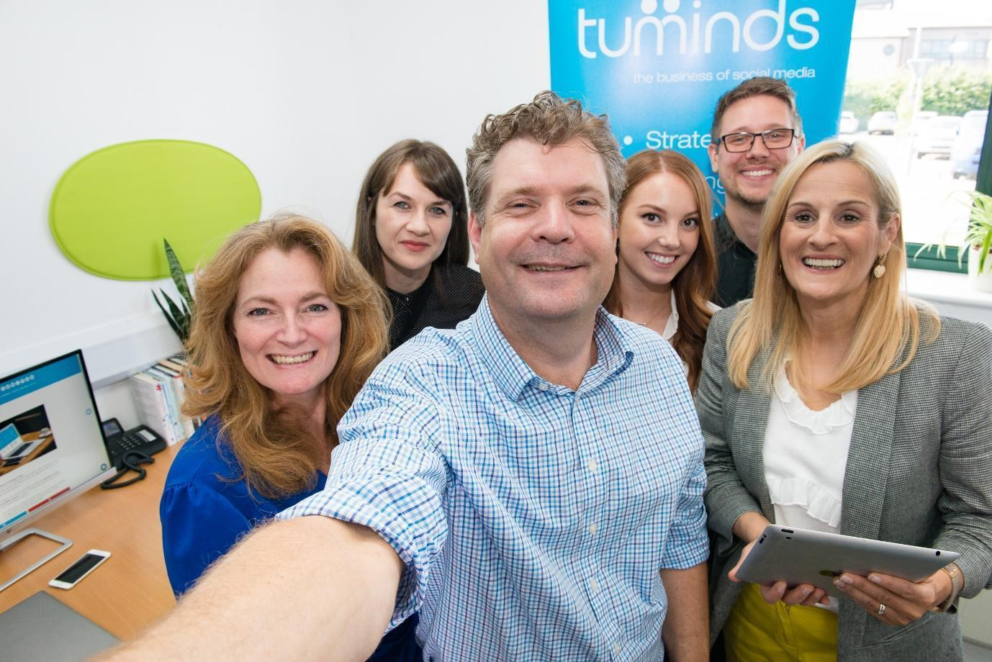



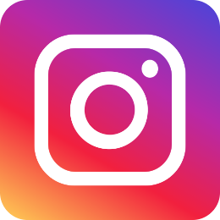
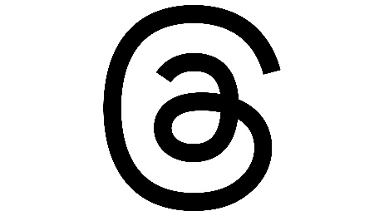





Social Media Calendar 2026
Mix and match the social media channels you use most for your business
JANUARY
 | Suggested hashtags:  #DryJanuary #NewYearsDay #BankHoliday #NationalBirdDay #CleanYourDeskDay #BlueMonday #RobbieBurns #ChocolateCakeDay #PrivacyAware #NationalCroissantDay #HotChocolate  Quick AI tip: Ask your AI tool: “Give me three upbeat caption ideas to start the year with a positive tone for my business.” |  |  | Thursday 1st | Friday 2nd | Saturday 3rd | Sunday 4th
Social dates |  |  |  | New Year’s Day 🎉 | Bank Holiday | Festival of Sleep Day | World Braille Day
Facebook |  |  |  | Bank Holiday
X /Twitter |  |  |  | Start of Dry January!
Instagram
LinkedIn
 | Monday 5th | Tuesday 6th | Wednesday 7th | Thursday 8th | Friday 9th | Saturday 10th | Sunday 11th
Social dates | National Bird Day 🐦 | Nat’l Shortbread Day
Facebook | Twelth Night
X /Twitter
Instagram
LinkedIn
 | Monday 12th | Tuesday 13th | Wednesday 14th | Thursday 15th | Friday 16th | Saturday 17th | Sunday 18th
Social dates | Clean Your Desk Day |  |  |  |  | Int’l Mentoring Day
Facebook
X /Twitter
Instagram
LinkedIn
 | Monday 19th | Tuesday 20th | Wednesday 21st | Thursday 22nd | Friday 23rd | Saturday 24th | Sunday 25th
Social dates | Blue Monday | National Cheese Lover’s Day 🧀 | National Hug Day |  | National Pie Day 🥧 |  | Robbie Burns Night
Facebook |  | National Cheese Lover’s Day 🧀
X /Twitter
Instagram
LinkedIn
 | Monday 26th | Tuesday 27th | Wednesday 28th | Thursday 29th | Friday 30th | Saturday 31st
Social dates | Australia Day 🦘 | Chocolate Cake Day | National Lego Day/Data Privacy Day | National Puzzle Day | National Croissant Day | Hot Chocolate Day
Facebook | Spouses Day |  | National Lego Day/Data Privacy Day
X /Twitter
Instagram
LinkedIn
Tuminds tips:
• Review your analytics from last year to spot which channels and content types performed best, then plan more of what worked. A simple audit can guide your whole year.
• For February, prepare your Valentine’s promotions early. Create a clear landing page, update your Google Business Profile and plan social posts that point customers to one key offer.

Social Media Calendar 2026
FEBRUARY
 | Suggested hashtags:  #sixnations #GirlsInScience #WomenInScience #NationalPizzaDay #ValentinesDay #Galentines #Valentines #Bekind #Loveyourpetday #DigitalLearningDay #BAFTAS #DLDay #LondonFashionWeek #LFW #Lovemycat #Lovemydog #WorldThinkingDay #HotChili #ChineseNewYear  Quick AI tip: Use AI to refresh your visuals: “Suggest five post ideas using customer stories or testimonials for this month.” |  |  |  |  |  | Sunday 1st
Social dates |  |  |  |  |  |  | British Yorkshire Pudding Day
Facebook
X /Twitter
Instagram
LinkedIn
 | Monday 2nd | Tuesday 3rd | Wednesday 4th | Thursday 5th | Friday 6th | Saturday 7th | Sunday 8th
Social dates | National Sickie Day/Groundhog Day |  | World Cancer Day | Six Nations Rugby begins 🏉 |  | Ice-cream for breakfast day! 🍦
Facebook |  |  |  | World Nutella Day
X /Twitter
Instagram
LinkedIn
 | Monday 9th | Tuesday 10th | Wednesday 11th | Thursday 12th | Friday 13th | Saturday 14th | Sunday 15th
Social dates | National Pizza Day 🍕 | Safer Internet Day | Int’l Day of Women and Girls in Science👩🏻‍🔬 |  | Galentine’s Day 💕 | Valentine’s Day 💖
Facebook |  |  | Int’l Day of Women and Girls in Science👩🏻‍🔬 |  | World Radio Day | Library Lovers Day
X /Twitter
Instagram
LinkedIn
 | Monday 16th | Tuesday 17th | Wednesday 18th | Thursday 19th | Friday 20th | Saturday 21st | Sunday 22nd
Social dates |  | Chinese New Year  (17 Feb to 3 Mar) |  | London Fashion Week  Love Your Pet Day  🐶 🐱 🐹 | World Day of Social Justice | Care Day | BAFTAS 🎭/  World Thinking Day
Facebook |  | Random Acts of Kindness Day |  |  |  | Int’l Mother Language Day
X /Twitter |  | Pancake Day
Instagram
LinkedIn
 | Monday 23rd | Tuesday 24th | Wednesday 25th | Thursday 26th | Friday 27th | Saturday 28th
Social dates |  |  |  | Digital Learning Day/ National Chili Day |  | Brit Awards
Facebook |  |  |  | Digital Learning Day/ National Chili Day
X /Twitter
Instagram
LinkedIn
Tuminds tips:
• Use customer stories this month. Share a short testimonial on social, then link to a fuller case study or product page to support decision‑making.
• Start preparing content for March events such as Mother’s Day and Easter by drafting visuals and scheduling posts to avoid last‑minute work.

Social Media Calendar 2026
MARCH
 | Suggested hashtags:  #StDavidsDay #VisitInvernessLochNess #WorldWildlifeDay #WorldBookDay #BritishPieWeek #PancakeDay #InvernessHalfMarathon2026 #OSCARS #StPatricksDay #EarthHour #MothersDay #MotheringSunday #RedNoseDay #ComicRelief #Spring #ClocksForward  Quick AI tip:  Ask your AI tool: “Create a short caption that highlights a spring offer or new season product in a friendly, conversational style.” |  |  |  |  |  | Sunday 1st
Social dates |  |  |  |  |  |  | Start of Women’s  History Month
Facebook |  |  |  |  |  |  | Start of Women’s  History Month
X /Twitter
Instagram
LinkedIn
 | Monday 2nd | Tuesday 3rd | Wednesday 4th | Thursday 5th | Friday 6th | Saturday 7th | Sunday 8th
Social dates | British Pie Week🥧 | World Wildlife Day 🦓 |  | World Book Day 📚 | Employee Appreciation |  | Inverness Half Marathon
Facebook |  |  |  |  |  |  | Int’l Women’s Day
X /Twitter
Instagram
LinkedIn
 | Monday 9th | Tuesday 10th | Wednesday 11th | Thursday 12th | Friday 13th | Saturday 14th | Sunday 15th
Social dates | Commonwealth Day |  | No Smoking Day |  | World Sleep Day |  | Mother’s Day
Facebook |  |  |  |  |  |  | 98th OSCARS
X /Twitter
Instagram
LinkedIn
 | Monday 16th | Tuesday 17th | Wednesday 18th | Thursday 19th | Friday 20th | Saturday 21st | Sunday 22nd
Social dates |  | St Patrick’s Day 🍀 | Global Recycling Day |  | Red Nose Day 🤡 | World Poetry Day | World Water Day
Facebook |  | Pancake Day 🥞 |  |  | First Day of Spring
X /Twitter
Instagram
LinkedIn
 | Monday 23rd | Tuesday 24th | Wednesday 25th | Thursday 26th | Friday 27th | Saturday 28th | Sunday 29th
Social dates | World Met Day |  |  |  |  | Earth Day Hour 🌎 | BST starts Clocks Forward
Facebook
X /Twitter
Instagram
LinkedIn
 | Monday 30th | Tuesday 31st | Tuminds tips:  • Add a spring update to your website. Refresh images, check broken links and update product or service descriptions to support better SEO.  • Create Easter‑themed posts now. Plan a small offer or limited product bundle that you can promote across email and social channels.
Social dates
Facebook
X /Twitter
Instagram
LinkedIn

Social Media Calendar 2026

APRIL
 | Quick AI tip:  Ask: “Give me three simple ways to repurpose this week’s main post into Stories, Reels or a carousel.” |  |  | Wednesday 1st | Thursday 2nd | Friday 3rd | Saturday 4th | Sunday 5th
Social dates |  |  |  | April Fool’s Day 🤣 |  | Good Friday | Easter Saturday 🐰 | Easter Sunday
Facebook
X /Twitter
Instagram
LinkedIn
 | Monday 6th | Tuesday 7th |  | Wednesday 8th | Thursday 9th | Friday 10th | Saturday 11th | Sunday 12th
Social dates |  | World Health Day |  |  | US Masters Golf 🏌️‍♂️ | National Siblings Day 👩‍👦‍👦 | Grand National 🏇🏻
Facebook |  |  |  |  |  |  | National Pet Day 🐈
X /Twitter
Instagram
LinkedIn
 | Monday 13th | Tuesday 14th |  | Wednesday 15th | Thursday 16th | Friday 17th | Saturday 18th | Sunday 19th
Social dates |  | Garden Day 🌻 |  | World Art Day 👨🏻‍🎨
Facebook
X /Twitter
Instagram
LinkedIn
 | Monday 20th | Tuesday 21st |  | Wednesday 22nd | Thursday 23rd | Friday 24th | Saturday 25th | Sunday 26th
Social dates |  | National Tea Day ☕ |  | Earth Day 🌍 | St George’s Day/Shakespeare Day |  |  | Etape Loch Ness 🚴🏼‍♀️ /London Marathon
Facebook
X /Twitter
Instagram
LinkedIn
 | Monday 27th |  | Tuesday 28th | Wednesday 29th | Thursday 30th | Suggested hashtags:  #AprilFoolsDay #GardenDay #GoodFriday #Easter #EasterSunday #USMasters #Grand National #NationalPetDay #NationalTeaDay #WorldArt Day #EarthDay #StGeorgesDay #Shakespeare Day #EtapeLochNess #EtapeLochNess2026 #Letsdance #Allthatjazz
Social dates |  |  | World Day for Safety and Health at Work | Int’l Dance Day 💃🕺 | Int’l Jazz Day 🎷🎺
Facebook
X /Twitter
Instagram
LinkedIn
Tuminds tips:
• Repurpose your main content each week into Stories, short videos or a simple carousel. This helps more people see your message without extra effort.
• Prepare for May Bank Holiday and local events by creating your graphics and scheduling key promotional posts in advance.
Social Media Calendar 2026
MAY
 | Suggested hashtags:  #MayDay #StarWarsDay #MayThe4thBeWithYou #NationalSpaceDay #WorldRedCrossDay #EuropeDay #EatWhatYouWantDay #WorldCocktailDay #WorldBakingDay #Food&DrinkFestival 2026 #EurovisionSongContest #ChelseaFlowerShow #TheGatheringFestival #WineDay #SpringBankHoliday #EUFA #HappyBirthdayTuminds  Quick AI tip: Improve accessibility: “Write clear and concise alt text for an image of ___.” (Add your own image description.) |  |  |  | Friday 1st | Saturday 2nd | Sunday 3rd
Social dates |  |  |  |  | May Day
Facebook
X /Twitter
Instagram
LinkedIn
 | Monday 4th | Tuesday 5th | Wednesday 6th | Thursday 7th | Friday 8th | Saturday 9th | Sunday 10th
Social dates | Star Wars Day 🚀  Early May Bank Hol |  | 3-year Anniversary of King’s Coronation 👑 | World Password Day | World Red Cross Day | Europe Day | Etape Caledonia
Facebook |  |  |  |  |  |  | National Children’s Day
X /Twitter
Instagram
LinkedIn
 | Monday 11th | Tuesday 12th | Wednesday 13th | Thursday 14th | Friday 15th | Saturday 16th | Sunday 17th
Social dates | Eat What You Want Day 🍽️ |  | World Cocktail Day 🍸 |  | Int’l Day of Families | Eurovision Song Contest | World Baking Day 🍰
Facebook |  |  |  |  |  | Men’s FA Cup Final
X /Twitter
Instagram
LinkedIn
 | Monday 18th | Tuesday 19th | Wednesday 20th | Thursday 21st | Friday 22nd | Saturday 23rd | Sunday 24th
Social dates |  | Chelsea Flower Show | World Bee Day 🐝 |  |  | Food & Drink Festival
Facebook |  | 🌸 (Tues to Sat) 🌿 |  |  |  | (Sip & Savour)
X /Twitter
Instagram
LinkedIn
 | Monday 25th | Tuesday 26th | Wednesday 27th | Thursday 28th | Friday 29th | Saturday 30th | Sunday 31st
Social dates | Spring Bank Holiday |  |  |  | National Biscuit  Day 🍪 | EUFA Champions ⚽ League Final
Facebook | National Wine Day 🍷 |  |  |  |  | Tuminds 20th Birthday
X /Twitter |  |  |  |  |  | The Gathering Festival
Instagram
LinkedIn
Tuminds tips:
• Check your website’s mobile experience. Most users browse on mobile in summer, so ensure fast loading times and clear calls to action.
• Begin preparing Father’s Day content for June. Draft product spotlights or experience ideas and gather any images you’ll need.
Social Media Calendar 2026
JUNE
 | Monday 1st | Tuesday 2nd | Wednesday 3rd | Thursday 4th | Friday 5th | Saturday 6th | Sunday 7th
Social dates | Pride Month 🌈 |  | World Bicycle Day 🚴‍♀️ | National Cheese Day 🧀 | Fish & Chips Day
Facebook |  |  |  |  | World Environment Day
X /Twitter
Instagram
LinkedIn
 | Monday 8th | Tuesday 9th | Wednesday 10th | Thursday 11th | Friday 12th | Saturday 13th | Sunday 14th
Social dates | Best Friends Day 💛 |  |  |  |  | World Gin Day 🍸 | World Blood Donor Day
Facebook |  |  |  |  |  | Trooping The Colour
X /Twitter
Instagram
LinkedIn
 | Monday 15th | Tuesday 16th | Wednesday 17th | Thursday 18th | Friday 19th | Saturday 20th | Sunday 21st
Social dates | Beer Day Britain 🍻 |  | Thank a Teacher Day | The Royal Highland Show |  |  | Father’s Day /  Summer Solstice ☀️
Facebook |  |  | Int’l Picnic Day | 🐄 (Thurs to Sun) 🚜
X /Twitter
Instagram
LinkedIn
 | Monday 22nd | Tuesday 23rd | Wednesday 24th | Thursday 25th | Friday 26th | Saturday 27th | Sunday 28th
Social dates |  | National Pink Day! |  |  | Take your dog to work day 🐶 | Armed Forces Day
Facebook
X /Twitter
Instagram
LinkedIn
 | Monday 29th | Tuesday 30th | Suggested hashtags:  #PrideMonth #FishandChipsDay #WorldEnvironmentDay #BestFriendsDay #WorldGinDay #ChampionsLeagueFinal #WorldBloodDonorDay #NationalBeerDay #BeerDayBritain #ThankaTeacherDay #Father’sDay #JuneSolstice #SummerSolstice #TroopingTheColour #NationalPinkDay #ArmedForcesDay #WorldSocialMediaDay #Wimbledon2026  Quick AI tip:  For engagement: “Suggest three question-style posts that would encourage my audience to comment.”
Social dates | Wimbledon 2026 🎾 | World Social Media Day
Facebook | (29th June to 12th July)
X /Twitter
Instagram
LinkedIn
Tuminds tips:
• Create more interactive posts such as questions, polls or quick quizzes. These help boost visibility during quieter summer months.
• Prepare July content in advance, especially if your business is busy with tourism or summer events. Draft posts and email content early.

Social Media Calendar 2026
JULY
 | Quick AI tip:  Ask AI to help brainstorm: “Give me five seasonal content ideas suitable for summer for a UK audience.” |  |  | Wednesday 1st | Thursday 2nd | Friday 3rd | Saturday 4th | Sunday 5th
Social dates |  |  |  |  | World UFO Day 🛸 |  | Tour de France begins | Nat’l Thankyou Day
Facebook |  |  |  |  | British Grand Prix |  | (4 to 26 July)
X /Twitter |  |  |  |  | 🏎️ (2 to 5 July) 🏎️
Instagram
LinkedIn
 | Monday 6th | Tuesday 7th |  | Wednesday 8th | Thursday 9th | Friday 10th | Saturday 11th | Sunday 12th
Social dates |  | World Chocolate Day 🍫 |  | Amazon Prime Day |  |  | Inverness Highland Games
Facebook |  |  |  |  |  |  | World Population Day
X /Twitter
Instagram
LinkedIn
 | Monday 13th | Tuesday 14th |  | Wednesday 15th | Thursday 16th | Friday 17th | Saturday 18th | Sunday 19th
Social dates |  |  |  | National Hot Dog Day 🌭 |  | World Emoji Day 😃 |  | National Ice-cream Day 🍦
Facebook |  |  |  |  |  |  |  | FIFA World Cup Final
X /Twitter
Instagram
LinkedIn
 | Monday 20th | Tuesday 21st |  | Wednesday 22nd | Thursday 23rd | Friday 24th | Saturday 25th | Sunday 26th
Social dates | Moon Landing An’sary |  |  |  |  |  | Cheese & Wine Day | Parent’s Day 👨‍👩‍👧‍👦
Facebook |  |  |  |  |  |  | 🧀 🍷
X /Twitter
Instagram
LinkedIn
 | Monday 27th |  | Tuesday 28th | Wednesday 29th | Thursday 30th | Friday 31st | Suggested hashtags:  #TourdeFrance #WorldUFODay #WorldChocolateDay #cheeseandwine #britishgp #britishgrandprix #HighlandGames #AmazonPrimeDay #IceCreamDay #WorldEmojiDay #NationalHotDogDay #Belladrum2026 #Bella #BelladrumTartanHeartFestival2026
Social dates |  |  |  | Nat’l Lipstick Day 💄 | Belladrum Tartan Heart Festival 2026 | Belladrum Tartan Heart Festival 2026
Facebook |  |  |  |  | Int’l Friendship Day 
X /Twitter
Instagram
Tuminds tips:
• Share more behind‑the‑scenes content. Summer is ideal for informal, friendly updates that build trust and familiarity.
• Prepare your August offers now. If you run back‑to‑school or end‑of‑summer promotions, start mapping out your posts and newsletters.
Social Media Calendar 2026
AUGUST
 | Suggested hashtags:  #Belladrum2026 #Bella #BelladrumTartanHeartFestival2026 #WorldWideWebDay #GirlfriendsDay #Sistersday #Sisters #InternationalCatDay #BookLoversDay #NationalLazyDay #WorldElephantDay #NationalProseccoDay #WorldPhotographyDay #NationalDogDay #NationalBurgerDay #USOpen  Quick AI tip:  Try: “Draft three light, informal captions suitable for behind-the-scenes summer posts.” |  |  |  |  | Saturday 1st | Sunday 2nd
Social dates |  |  |  |  |  | Belladrum | Sisters’ Day 💕
Facebook
X /Twitter
Instagram
LinkedIn
 | Monday 3rd | Tuesday 4th | Wednesday 5th | Thursday 6th | Friday 7th | Saturday 8th | Sunday 9th
Social dates | Scottish Bank Holiday |  |  |  | Int’l Beer Day 🍺 | Int’l Cat Day 🐈 | Book Lovers Day 📚
Facebook |  |  |  |  |  |  | National Lazy Day
X /Twitter
Instagram
LinkedIn
 | Monday 10th | Tuesday 11th | Wednesday 12th | Thursday 13th | Friday 14th | Saturday 15th | Sunday 16th
Social dates |  | National Son and Daughter Day 👨‍👩‍👧‍👦 | World Elephant Day 🐘 | Prosecco Day 🍾 |  | National Relaxation Day
Facebook |  | National Son and Daughter Day 👨‍👩‍👧‍👦 |  |  |  | National Relaxation Day
X /Twitter
Instagram
LinkedIn
 | Monday 17th | Tuesday 18th | Wednesday 19th | Thursday 20th | Friday 21st | Saturday 22nd | Sunday 23rd
Social dates | 🧁 Cupcake Day 🧁 |  | World Photography Day | National Radio Day 📻 | World Entrepreneurs’ Day
Facebook |  |  |  |  | World Entrepreneurs’ Day
X /Twitter
Instagram
LinkedIn
 | Monday 24th | Tuesday 25th | Wednesday 26th | Thursday 27th | Friday 28th | Saturday 29th | Sunday 30th
Social dates |  |  | Int’l Dog Day 🐶 | National Burger Day |  |  | US Open begins 🎾
Facebook |  |  | British Masters Golf |  |  |  | (30 Aug to 13 Sept)
X /Twitter
Instagram
LinkedIn
 | Monday 31st | Tuminds tips:  • Review which platforms bring you the most engagement. Focus your efforts there for the rest of the year instead of spreading yourself too thin.  • Start planning autumn content. Draft early ideas for September and October, including any educational posts and seasonal promotions.
Social dates | Summer Bank Holiday
Facebook
X /Twitter
Instagram
LinkedIn

Social Media Calendar 2026
SEPTEMBER
 | Quick AI tip:  Use: “Help me plan one informative post and one educational post for my industry this month.” | Tuesday 1st | Wednesday 2nd | Thursday 3rd | Friday 4th | Saturday 5th | Sunday 6th
Social dates |  |  |  |  |  | National Charity Day | Read a Book Day 📙
Facebook
X /Twitter
Instagram
LinkedIn
 | Monday 7th | Tuesday 8th | Wednesday 9th | Thursday 10th | Friday 11th | Saturday 12th | Sunday 13th
Social dates |  | International Literacy Day 📖 | Emergency Services Day 🚑🚒🚓 |   World Suicide Prevention Day |  |  |   Roald Dahl Day
Facebook
X /Twitter
Instagram
LinkedIn
 | Monday 14th | Tuesday 15th | Wednesday 16th | Thursday 17th | Friday 18th | Saturday 19th | Sunday 20th
Social dates |  |  | 100 days til  Christmas! 🎄 |  |  | Talk Like a Pirate  Day 🏴‍☠️ | World Clean Up Day
Facebook |  |  | 100 days til  Christmas! 🎄
X /Twitter
Instagram
LinkedIn
 | Monday 21st | Tuesday 22nd | Wednesday 23rd | Thursday 24th | Friday 25th | Saturday 26th | Sunday 27th
Social dates | International Day of Peace ✌️ | Hobbit Day | Autumn Equinox 🍂 | National Fitness Day 🤸‍♀️🤾🏋️ | World’s Biggest Coffee Morning ☕ | World Tourism Day | Loch Ness Marathon
Facebook |  |  |  |  | National Daughter’s Day 🥰 | British Food Fortnight begins | World Tourism Day
X /Twitter
Instagram
LinkedIn
 | Monday 28th | Tuesday 29th | Wednesday 30th | Suggested hashtags:  #InternationalDayofCharity #ReadaBookDay #InternationalLiteracyDay #EmergencyServicesDay #WorldSuicidePreventionDay #SuicidePreventionDay #WSPD #RoaldDahlDay #WifeAppreciationDay #OnlineLearningDay #100DaysUntilChristmas #TalkLikeaPirateDay #InternationalDayofPeace #HobbitDay #FirstDayofAutumn #NationalDaughtersDay #WorldTourismDay #NationalSonsDay #LochNessMarathon #LochNessMarathon2026 #WorldHeartDay
Social dates | National Son’s Day 🥰 | World Heart Day ❤️ | Int’l Podcast Day 🎙️
Facebook
X /Twitter
Instagram
LinkedIn
Tuminds tips:
• Update your social media bios with clearer descriptions and a strong link to your main offer or booking page. Small changes boost conversions.
• Start preparing your Black Friday strategy. Plan early to avoid rushed decisions and create value‑focused messaging.
Social Media Calendar 2026

OCTOBER
 | Suggested hashtags:  #GirlfriendsDay #BoyfriendsDay #BuyBritishDay #WorldMentalHealthDay #WorldTeachersDay #UKCoffee Week #InternationalGinandTonicDay #GinandTonic #GinTon #UNDay #WorldPastaDay #ClocksGoBack #RSPB #Halloween  Quick AI tip: Seasonal prompt: “Suggest three autumn-themed post ideas that fit a professional but friendly tone.” |  |  |  | Thursday 1st | Friday 2nd | Saturday 3rd | Sunday 4th
Social dates |  |  |  |  | Girlfriends’ Day 🥰 | World Smile Day 😊 | Buy British Day | Grandparents’ Day 🥰
Facebook |  |  |  |  | National Poetry Day |  | Boyfriends’ Day 🥰
X /Twitter
Instagram
LinkedIn
 | Monday 5th | Tuesday 6th |  | Wednesday 7th | Thursday 8th | Friday 9th | Saturday 10th | Sunday 11th
Social dates | World Teachers’ Day |  |  |  |  | World Egg Day 🥚 | World Mental Health Awareness Day
Facebook
X /Twitter
Instagram
LinkedIn
 | Monday 12th | Tuesday 13th |  | Wednesday 14th | Thursday 15th | Friday 16th | Saturday 17th | Sunday 18th
Social dates |  | UK Coffee Week ☕ |  |  |  |  | National Pasta Day
Facebook
X /Twitter
Instagram
LinkedIn
 | Monday 19th | Tuesday 20th |  | Wednesday 21st | Thursday 22nd | Friday 23rd | Saturday 24th | Sunday 25th
Social dates | Int’l Gin and Tonic Day |  |  | Back to the Future Day |  |  | United Nations Day | BST ends - Clocks back 1 hour
Facebook |  |  |  |  |  |  |  | World Pasta Day 🍝
X /Twitter
Instagram
LinkedIn
 | Monday 26th |  | Tuesday 27th | Wednesday 28th | Thursday 29th | Friday 30th | Saturday 31st
Social dates |  |  |  |  | RSPB Feed The Birds Day 🐦 |  | Halloween 🎃
Facebook |  |  |  |  |  |  | World Cities Day
X /Twitter
Instagram
LinkedIn
Tuminds tips:
• Share helpful, autumn‑themed posts such as tips, FAQs or product highlights. Seasonal posts often perform well as audiences shift indoors.
• Prepare all November promotions now. Draft Black Friday posts, email subject lines and simple graphics ahead of time.
Social Media Calendar 2026
NOVEMBER
 | Suggested hashtags:  #Movember #WorldSandwichDay #BonfireNight #FireworksNight #GuyFawkesNight #RemembranceSunday #RemembranceDay #WorldKindnessDay #KingCharlesBirthday #WorldChildrensDay #WorldHelloDay #NationalEspressoDay #ThanksgivingDay #BlackFriday #StAndrewsDay #SmallBusinessSaturday #CyberMonday  Quick AI tip:  For promotions: “Create two short captions introducing an offer without sounding salesy.” |  |  |  |  |  | Sunday 1st
Social dates |  |  |  |  |  |  | All Saints Day/Movember
Facebook |  |  |  |  |  |  | World Vegan Day
X /Twitter |  |  |  |  |  |  | National Authors’ Day
Instagram
LinkedIn
 | Monday 2nd | Tuesday 3rd | Wednesday 4th | Thursday 5th | Friday 6th | Saturday 7th | Sunday 8th
Social dates |  | Sandwich Day 🥪 | Nat Roast Dinner Day | Bonfire Night ✨ |  |  | Remembrance Sunday
Facebook
X /Twitter
Instagram
LinkedIn
 | Monday 9th | Tuesday 10th | Wednesday 11th | Thursday 12th | Friday 13th | Saturday 14th | Sunday 15th
Social dates |  |  | Remembrance Day |  | World Kindness Day | King Charles b’day
Facebook
X /Twitter
Instagram
LinkedIn
 | Monday 16th | Tuesday 17th | Wednesday 18th | Thursday 19th | Friday 20th | Saturday 21st | Sunday 22nd
Social dates |  |  |  | Int’l Men’s Day | World Children’s Day | World Hello Day 👋
Facebook |  |  |  |  |  | World Television Day
X /Twitter
Instagram
LinkedIn
 | Monday 23rd | Tuesday 24th | Wednesday 25th | Thursday 26th | Friday 27th | Saturday 28th | Sunday 29th
Social dates | National Espresso Day |  |  |  | Black Friday | Small Business Saturday | First Advent Sunday
Facebook
X /Twitter
Instagram
LinkedIn
 | Monday 30th | Tuminds tips:  • Create a warm thank‑you message for your customers and schedule it for early December. These posts help strengthen loyalty.  • Review your 2026 content performance. Identify what you want to continue, change or stop as you move toward next year.
Social dates |   St Andrew’s Day
Facebook | Cyber Monday
X /Twitter
Instagram
LinkedIn

Social Media Calendar 2026
DECEMBER
 | Quick AI tip:  Ask: “Help me draft a warm end-of-year message for my customers, suitable for social media.” | Tuesday 1st | Wednesday 2nd | Thursday 3rd | Friday 4th | Saturday 5th | Sunday 6th
Social dates |  | First day of Advent |  | Int’l Day of Disabled Persons | National Cookie Day 🍪 | Int’l Volunteer Day
Facebook |  | Giving Tuesday
X /Twitter
Instagram
LinkedIn
 | Monday 7th | Tuesday 8th | Wednesday 9th | Thursday 10th | Friday 11th | Saturday 12th | Sunday 13th
Social dates |  |  | Christmas Card Day | Human Rights Day
Facebook |  |  |  | Christmas Jumper Day
X /Twitter
Instagram
LinkedIn
 | Monday 14th | Tuesday 15th | Wednesday 16th | Thursday 17th | Friday 18th | Saturday 19th | Sunday 20th
Social dates | Green Monday |  |  |  | Mad Friday
Facebook
X /Twitter
Instagram
LinkedIn
 | Monday 21st | Tuesday 22nd | Wednesday 23rd | Thursday 24th | Friday 25th | Saturday 26th | Sunday 27th
Social dates | First Day of Winter ❄️ |  |  | Christmas Eve 🎄 | Christmas Day 🎅 | Boxing Day 🎁
Facebook
X /Twitter
Instagram
LinkedIn
 | Monday 28th | Tuesday 29th | Wednesday 30th | Thursday 31st | Suggested hashtags:  #Advent #GivingTuesday #NationalCookieDay #HumanRightsDay #ChristmasJumperDay #ChristmasCardDay #HumanRightsDay #ChristmasJumperDay #BillofRightsDay #FirstDayofWinter #ChristmasEve #ChristmasDay #Christmas #MerryChristmas #HappyChristmas #BoxingDay #Hogmanay #NewYearsEve #NYE #HappyNewYear #NewYearsDay
Social dates |  |  |  | Hogmanay! 🍾🥂
Facebook
X /Twitter
Instagram
LinkedIn
Tuminds tips:
• Share your highlights of the year. Round‑up posts perform well and show the human side of your business.
• Prepare your January digital housekeeping tasks. Plan a mini audit covering social platforms, your website and your email list.
The social media landscape is continually changing. For social media training, support and strategy please get in touch. If you have any social media questions, you can send us a message on any of our platforms or use #asktuminds in your posts/tweets.



